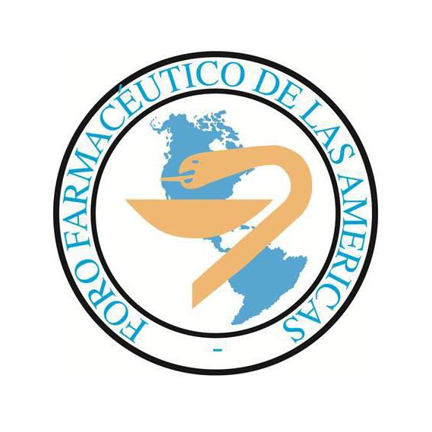

**2022 - 2023 Annual Report of the Regional Pharmaceutical Forums to the FIP Council**

**Forum name:** Pharmaceutical Forum of the Americas

**Executive committee members (position, name, country):**

|  |  |  |
| --- | --- | --- |
| Position | Name | Country |
| President | **Prof Dr Eduardo Savio** (up to 19th November 2022)  **QF Carlos Lacava** (since 19th November 2022) | **Uruguay**  **Uruguay** |
| Vice-president | **Dr Magaly Rodríguez de Bittner** | **USA** |
| Treasurer | **QF Andrea Bagnulo** | **Uruguay** |
| Director of Pharmaceutical Education | **Dr William Peres** (up to 19th November 2022)  **Dr Gladys Lugo** (since 19th November 2022) | **Brazil**  **Paraguay** |
| Director of Professional  Practice | **Dr Nuria Montero** (up to 19th November 2022)  **Dr Diego Galvis** (since 19th November 2022) | **Costa Rica**  **Colombia** |

**Secretariat (person in charge and contact details):**

|  |  |
| --- | --- |
| Position: | Professional Secretary |
| Name: | **Dr Fernando Puello** |
| Address: | **Colegio Nacional de Químicos Farmacéuticos de Colombia** |
|  | **Teusaquillo, Bogotá, Carrera 16 # 31 A – 30** |
| Country: | **Colombia** |
| Telephone numbers: | **+5717501142 (CNQFC), +573187441015 (F. Puello)** |
| Email address: | **ffa@forofarmaceutico.org** |
| Website: | **https://forofarmaceutico.org/** |

**Current Member Organisations (name of organisations, country)**

|  |  |  |  |
| --- | --- | --- | --- |
|  | Name of Organisation | Country | Number of Members |
| 1 | Confederación Farmacéutica Argentina | Argentina | 20.000 |
| 2 | Conselho Federal de Farmácia do Brasil | Brazil | 144.000 |
| 3 | Sociedad Boliviana de Ciencias Farmacéuticas | Bolivia | 280 |
| 4 | Colegio Nacional de Químicos Farmacéuticos de Colombia | Colombia | 200 |
| 5 | Colegio de Farmacéuticos de Costa Rica | Costa Rica | 937 |
| 6 | Colegio de Químicos, Bioquímicos y Farmacéuticos de Pichincha | Ecuador | 240 |
| 7 | Colegio Nacional de Farmacéuticos de Panamá | Panamá | 500 |
| 8 | Asociación de Químicos Farmacéuticos del  Paraguay | Paraguay | 600 |
| 9 | Asociación de Química y Farmacia del Uruguay | Uruguay | 789 |
| 10 | American Pharmacists Association | USA | 63.000 |
| 11 | American Society of Health-System Pharmacists | USA | 43.000 |

**Main activities of the Forum between June 2022 and May 2023:**

1) Regular meetings of the Executive Committee (12 online meetings and 1 face-to-face meetings).

2) Articulation of activities with PAHO along the period.

3) Participation of the President and the Professional Secretary in FIP Congress 2022 (Seville, Spain, from 18th to 22nd September):

- Council meeting

- PFA’s Meeting, September 19th from 15:00 to 16:30.

4) Workshop PAHO-FFA: “Dissemination strategy and progressive implementation of the system of indicators for pharmaceutical services (SF) based on PHC”, held in Bogota, Colombia, on 17th November 2022.

5) PFA Academic Event: “Contributions of the Pharmacist to Health in the Americas”, held in Bogota, Colombia, on 18th November 2022.

6) Celebration of PFA’s General Annual Meeting in Bogota, Colombia, on 19th November 2022 in hybrid mode

- PFA authorities were renovated, so the Executive Committee has a new President, a new Director of Pharmaceutical Practice, and a new Director of Pharmaceutical Education

- Professional Secretary goes from Costa Rica to Colombia

- Adoption of two declarations:

a) Declaration of Bogota on Pharmaceutical Services based on Primary Healthcare

b) Declaration of Bogota on support to the National Technical Groups of Pharmaceutical Services based on Primary Health Care, and to the quality measurement system based on indicators.

7) Call for projects between member organizations to be funded by PFA (December 2022).

8) Selection and nomination of postulants to the FIP Foundation Early Career Leadership Development (ECLD) Scholarship to Brisbane Congress 2023 (March 2023).

9) Approval of the first reports of the project which were supported by PFA during 2022 – 2023 (March 2023):

- “Support for the development of interprofessional education in the Schools and Faculties of Pharmacy of the Region of the Americas as a training strategy for the pharmacist” (Pan American Conference on Pharmaceutical Education and the Pharmaceutical Forum of the Americas)

- “Development of pharmaceutical services in immunization against the influenza virus in community pharmacies in Uruguay” (Uruguay)

- “Professional services in the community pharmacy: communication and promotion of

self-care practices” (Uruguay).

10) Evaluation of the two projects presented to the call done for projects to be funded by the PFA during 2023-2024. Both projects were accepted:

a) “Promotion of self-care practices in Patients with Type 2 Diabetes from the Pharmacy of two tertiary centres of the Social Welfare Institute from April to December 2023” (Paraguay)

b) “Medication adherence of hypertensive patients from the Adult Cardiology Department of the Hospital de Clínicas de Paraguay through interventions provided by mobile phone” (Paraguay).

9) As part of the work of the technical advisory group to evaluate and promote the participation of the pharmacists in self-care and self-medication formed by the PFA, with the collaboration of the Latin American Association of Responsible Self-Care (ILAR), a MoU was signed with FIP to translate into Spanish the FIP publication “Empowering self-care. A handbook for pharmacists” and this publication will include an additional section authored by the PFA, to describe specific experiences and needs with regards to the role of pharmacists in self-care in the region of the Americas (January 2023).

11) As a part of the cooperation agreement signed with the Society of Pharmacists in Infectious Diseases of the United States (SPID), the pharmacists selected from three countries of the region (Argentina, Colombia, and Costa Rica) in 2022 go on with the training in this important area of professional practice.

12) The Virtual course on Pharmaceutical Services in Primary Health Care, organised and promoted in coordination with the Pan American Health Organization (PAHO) ended in October 2022.

13) The working group on Antimicrobial Resistance has maintained meetings with the scholarship holders of the SPID.

14) On 17th May 2023 the webinar “Knowing the Pharmaceutical Forum of the Americas” was offered.

15) Edition of nine issues of the e-Newsletter.

16) Efforts have been made to reincorporate the Confederación Farmacéutica Argentina (COFA) as an active member of PFA.

**Highlights of events in the region between June 2022 and May 2023 where the Forum was involved:**

1) Workshop PAHO-FFA: “Dissemination strategy and progressive implementation of the system of indicators for pharmaceutical services (SF) based on PHC”, held in Bogota, Colombia, on 17th November 2022.

2) PFA Academic Event: “Contributions of the Pharmacist to Health in the Americas”, held in Bogota, Colombia, on 18th November 2022.

**Key collaboration with other stakeholders of the region (including the WHO Regional Office and other organisations)**

Collaboration with PAHO.

Participation of PFA in the Pan-American Conference on Pharmaceutical Education.

Collaboration with Latin American Association of Responsible Self-Care (ILAR).

Scholarships from with the Society of Pharmacists in Infectious Diseases of the United States (SPID).

**Current projects:**

1) Calendar of webinar for the remain of the year.

2) A new call for scholarships from the Society of Pharmacists in Infectious Diseases of the United States (SPID).

3) Working with FIP in “A Roadmap for Pharmacy in Latin America”.

4) Enlarge presence of PFA in the region.

5) Consolidation of the role of the PFA in FIP.

**Main challenges:**

1) Enhance and improve communication and participation of the PFA member organizations.

2) Increase the number of national organizations which are members of the PFA.

3) Establish new of financing sources to support the execution of projects in the region.

4) Consolidate the role of the PFA and the other Regional Forums in FIP's structure.

5) Increase the recognition of the pharmacist as a health professional in the region.