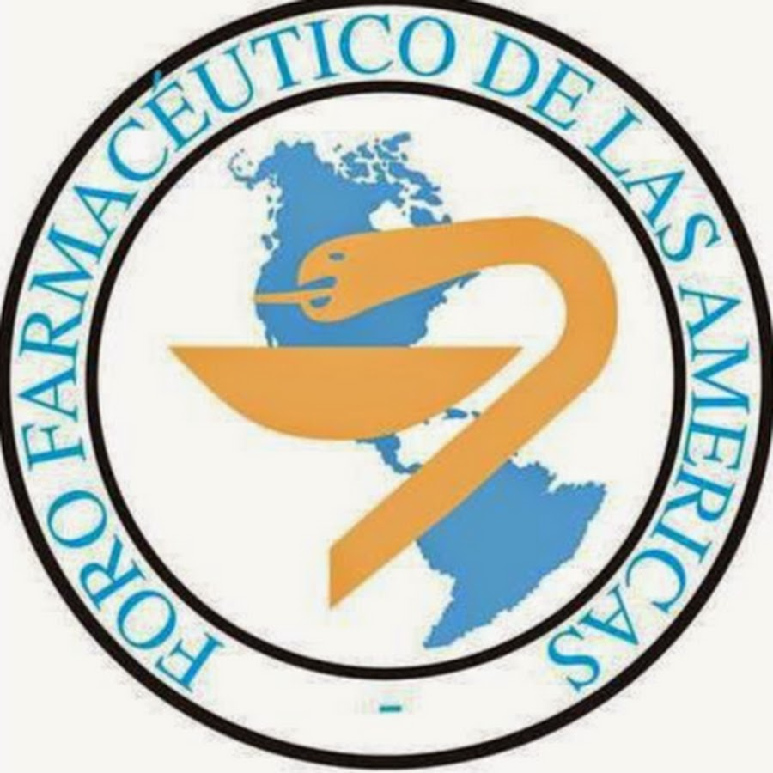

2021 Annual Report of the Regional Pharmaceutical Forums to the FIP Council

Forum name: Pharmaceutical Forum of the Americas

Executive committee members (position, name, country):

Position | Name | Country
President | Dr Eduardo Savio  (2019-2021) | Uruguay
Vice-president | Dr Magaly Rodríguez de Bittner  (2020-2022) | United States of America
Treasurer | Dr Andrea Bagnulo  (2020-2022) | Uruguay
Director of  Pharmaceutical Education | Dr William Peres  (2019-2021) | Brazil
Director of Pharmaceutical  Practice | Dr Nuria Montero  (2019-2021) | Costa Rica

Secretariat (person in charge and contact details):

Postion: | Professional Secretary
Name: | Yajaira Quesada
Address: | Colegio de Farmacéuticos de Costa Rica
Country: | Costa Rica
Telephone numbers: | +506 88285893
Email address: | ffa@forofarmaceutico.org
Website: | www.forofarmaceutico.org

Current Member Organisations (formal members) as of May 2020

 | Name of Organisation | Country | Number of Members
1 | Confederación Farmacéutica Argentina | Argentina | 20.000
2 | Conselho Federal de Farmácia do Brasil | Brazil | 144.000
3 | Sociedad Boliviana de Ciencias Farmacéuticas | Bolivia | 280
4 | Colegio Nacional de Químicos Farmacéuticos de Colombia | Colombia | 200
5 | Colegio de Farmacéuticos de Costa Rica | Costa Rica | 937
6 | Colegio de Químicos, Bioquímicos y Farmacéuticos de Pichincha | Ecuador | 240
7 | Colegio Nacional de Farmacéuticos de Panamá | Panamá | 500
8 | Asociación de Químicos Farmacéuticos del  Paraguay | Paraguay | 600
9 | Asociación de Química y Farmacia del Uruguay | Uruguay | 789
10 | American Pharmacists Association | USA | 63.000
11 | American Society of Health-System Pharmacists | USA | 43.000

Main activities of the Forum between May 2020 and June 2021:
1) One general assemblie were held: ordinary.
a) In the Ordinary General Assembly held on November 7th (in virtual mode due to the COVID-19 pandemic. The platform used was GotoMeeting), the main issues approved were:
- the renewal of the 2 of the Executive Committee positions for the 2020-2022 period: Vice-president and Treasure.
- the action plan and the budget for the period 2020-2021.
- report on the process of integrating regional pharmaceutical forums into the structure of the International Pharmaceutical Federation. Ratification of the integration of the Pharmaceutical Forum of the Americas to the structure of the International Pharmaceutical Federation.
2) Participation of the Pharmaceutical Forum of the Americas in the Virtual Congress of the International Pharmaceutical Federation. From September 4th to 25th, 2020, in the following events:
i) Meeting of the Pharmaceutical Forum of the Americas (Knowledge and reflection space). September 7th 2020: The president and the Technical Secretary presented the activities carried out by the Forum in the 2019-2020 period and the presentation of two projects financed by the competitive funds mechanism of the FFA during the periods 2016-2017 and 2019-2020 was made. The activity allowed to stimulate analysis and reflection on the challenges faced by the Pharmaceutical Forum of the Americas in the implementation of the changes required by the pharmaceutical profession in the region.
ii) 16/9- FIP Virtual Regional Workshop (Americas Region): “The roadmap for AMR Success in Pharmacy”, Doug Bourgoyne, Eduardo Savio and Sabiha Essack
3) Participation of President and Technical Secretary in the Regional Meeting as part of the implementation of the ONE FIP strategy and the integration of the forums regional pharmacists to its organizational structure, the International Pharmaceutical Federation delegated to the Pharmaceutical Forum of the Americas its representation in the meetings of the Council Directing and Regional Committee of WHO for the Americas that were held virtually on the 28th and September 29th of the current year.
4) Two grants in the amount of US$ 2.500 each were approved to partially support the following projects in the 2020-2021 period:
a) Establishment of technical criteria and tools for training for drug administration in educational centers in Costa Rica. (Costa Rica). Project execution dates are: from August 1st, 2020 to July 31st, 2021
b) TV monitoring phonic to support adherence to treatment of adolescent and young patients with liver transplants (Uruguay). Project execution dates are: November 1st, 2020 to October 31st, 2021.
5) Approval of the final report of the project Good practices for dispensing antibiotics in greatest demand in pharmacies in the province of Córdoba, Argentina (2019-2020). The execution of the project ended on May 31st, 2020. This is still an ongoing process because the final report is missing.
6) A call for projects to be partially supported by the PFA for member organizations was open until 31st March 2021. Two projects were received and evaluated, only one project was preselected for funding due to the fact that they had some areas that needed modifications prior to final approval. However, he did not pass the second evaluation. Eventhough one project passed to a second evaluation, finally no project could be approved.
7) An Standard Operating Procedure to guide Executive Committee meetings was approved.
8) Seven webinars were held in the following topics:
a) “Medicinal use of cannabis” (in Spanish) presented by Dra. Q.F. Cecilia Maldonado Corbo and Dra. Q.F. Marta Vásquez Mesa (Uruguay). Broadcasted on 24th June 2020 by GoToWebinar.109 participants.
b) “Actions of the pharmacist in an intensive care unit” (in Spanish) presented by Dr. Q.F. Willington Aníbal Montenegro Acosta (Ecuador). Broadcasted on 22th July 2020 by GoToWebinar.188 participants.
c) “Effects of COVID-19 on the health of healthcare professionals and future strategies prevention” (in Spanish) presented by Dr. Q.F. Aldo Álvarez Risco (Perú). Broadcasted on 26th August 2020 by GoToWebinar. 39 participants.
d) “Advances in the development of vaccines against COVID 19 e importance of vaccination in times of pandemic” (in Spanish) presented by Dra. María Luisa Ávila Aguero (Costa Rica). Broadcasted on 7th October 2020 by GoToWebinar.
e) “Vaccination reluctance: the role of the pharmacist in education in immunizations” (in Spanish) presented by Dr. Roberto Debagg (Argentina). Broadcasted on 28th October 2020 by GoToWebinar.
f) “Impact of the pharmacy on vaccination coverage: presentation of the results of the global survey and other tools of the Federation International Pharmaceutical” (in Spanish) presented by Dr. Gonçalo Sousa Pinto (Director of the Development and Transformation Area of the Profession, International Pharmaceutical Federation). Broadcasted on 26th November 2020 by GoToWebinar.
g) “The pharmacist in the prevention and management of vector-borne diseases:
a perspective of the Region of the Americas” (in Spanish) presented by Dra. Cristina Fernández Barrantes, Dra. Nuria Montero Chinchilla and Dra. Sofía Segura Cano (the three colleagues from Costa Rica). Broadcasted on 21th April 2021 by Zoom.
9) First Edition of Virtual course: Formulation and execution of projects pharmaceutical intervention (August 4th to December 18th, 2020). 38 participants (Argentina, Uruguay, Ecuador, Costa Rica and Panamá). With support from the College of Pharmacists of Costa Rica for the use of the virtual campus www.colfar2.com
10) Support to the Federal Council of Pharmacy of Brazil in the issuance of the new Clinical Practice Guide:
i)Signs and symptoms of gastrointestinal treatment. Heartburn (heartburn/pyrosis) and dyspepsia.
ii) Signs and symptoms respiratory Cough.
iii) Pharmacotherapeutic guide for the treatment of patients hospitalized with COVID-19.
11) Integration of Technical Groups of work to develop priority thematic axes:
i) Antimicrobial resistance and rational use of antibiotics. Coordinator: President
ii) Responsible self-medication. Coordinator: Vice-president.
12) Representation of the Pharmaceutical Forum of the Americas in the Intelligence and Data Commission of the International Federation.Two candidates were nominated and approved by FIP to participate in the Intelligence and Data Comission: By Virginia Olmos Botali (Uruguay) and María Lorena Quirós Luque (Costa Rica).
13) Thirteen meetings were regularly held by the Regular meetings of the Executive Committee (13 virtual meetings)
14) Developed tTen issues of the e-Newsletter were developed. One bulletin was produced per month from June 2020 to June 2021. Available in: http://www.forofarmaceutico.org/boletines/
15) Our PFA’s website: http://www.forofarmaceutico.org
16) Our Facebook page: https://bit.ly/3kAgyPU was updated and revised (it has 7769 followers, 457 more followers compared to the previous period).
17) Our PFA You Tube Channel was revised: https://bit.ly/2TmBVt6 (it has 558 subscribers, 347 more followers compared to the previous period) was revised.

Highlights of events in the region between May 2020 and June 2021 where the Forum was involved:
1) Participation of the President in the Regional Workshop of the Americas GRIP: the roadmap for the success of the antimicrobial resistance in the pharmacy. September 16th 2020. In this activity a roadmap was drawn up that allows addressing at the level of the Region of the Americas, the problem of antimicrobial resistance (ADR) from pharmacies and a working commitment was established for pharmacists to make AMR a priority health, both regionally and globally.
2) Participation of the President in the FIP Commission on Resistance to Antimicrobial launched on September 24th, 2020.
3) Participation of the Pharmaceutical Forum of the Americas as moderator in the event of the International Pharmaceutical Federation Regional needs and drivers to transform vaccination into the Americas region, 10th December, 2020.
4) Participation of the Pharmaceutical Forum of the Americas as moderator in the event Challenges from the virtuality in pharmaceutical education, organized by the Conference Pan American Pharmaceutical Education, November 24 th and December 1st 2020.
5) Participation of the Pharmaceutical Forum of the Americas in the construction of the commitment to transform vaccination from the pharmacy to the local, regional and global guided by the International Pharmaceutical Federation.
i) December 10th, 2020. Regional needs and drivers to transform vaccination.
ii) December 15th, 2020: From Regional to Global: Common Priorities for Action to transform vaccination.
iii) December 17th, 2020: IFJ World Summit: Commitment to Action to Transform vaccination at the pharmacy. a perspective of the Region of the Americas

6) Participation of the President, the Technical Secretary and Dra Ana Senatore (Collaborator, Uruguay) in the Diplomature in Professional Pharmaceutical Assistance Services offered by the College of Pharmaceuticals of the Province of Córdoba (April, Argentina)
7) Falta un seminario –“Episode 3: Communicable Diseases. “The pharmacist in the prevention and management of vector-borne diseases” (English). 28th April. Moderator: Gonzalo Sousa Pintos. Dr. Eduardo Savio (speaker)
8) Falta otro seminario: DG21L: Sustainability in pharmacy. 9th June. Moderator: Linda Bader (Lead for Workforce transformation and Development). Dr. Eduardo Savio (speaker)

Key collaboration with other stakeholders of the region (including the WHO Regional Office and other organisations)
1) Establishment of a collaboration plan for the Pharmaceutical Forum of the Americas with the Latin American Association of Responsible Self-Care (ILAR), 26th March, 2021. The purpose is to work on the implementation of joint activities that enhance the role of pharmacists in self-care in the Latin American scenario.
2) Letter of agreement signed with the American Pharmacists Association (APhA) to develop the certification program Pharmacy-based Immunization Delivery. 10 participants (Uruguay, Ecuador y Costa Rica).
Current projects:
1) The Executive Committee members will collaborate as co-organizer in the III Pharmaceutical Chemical Congress, organized by the Uruguayan Association of Chemistry and Pharmacy (AQFU) and the Ibero-Latin American Pharmaceutical Organization (OFIL-Uruguay) that will be held on August 6th, 13th, 20th and 27 th, 2021) 2) Delivery of a virtual self-learning course with tutoring: “Formulation and execution of pharmaceutical intervention projects”. Second Edition of Virtual course: Formulation and execution of projects pharmaceutical intervention (June 21th to November 7th, 2021). Is in progress (Argentina, Uruguay, Ecuador and Costa Rica). With support from the College of Pharmacists of Costa Rica for the use of the virtual campus www.colfar2.com
3) Layout of the technical document of a technical document: “Pharmaceutical services in immunization: Contributions, experiences and implementation in the region of the Americas”

Main challenges:
- Establishing strategical alliances with other pharmaceutical organizations in the region to develop activities of mutual interest.
- Raising funds to enable the financial support of new projects in the region.
- Increase the number of national organizations which are members of the PFA.
- To participate/contribute in the process of drafting and approval of the new "FIP Strategic Plan 2030".
- To define the role of the Regional Forums role and FIP's perspective to our organization.

